Andrew McClelland, Rony Besprozvanny and Ryan Fredrickson

KtCS User manual

# Register as New User

1. From the login screen click the register button.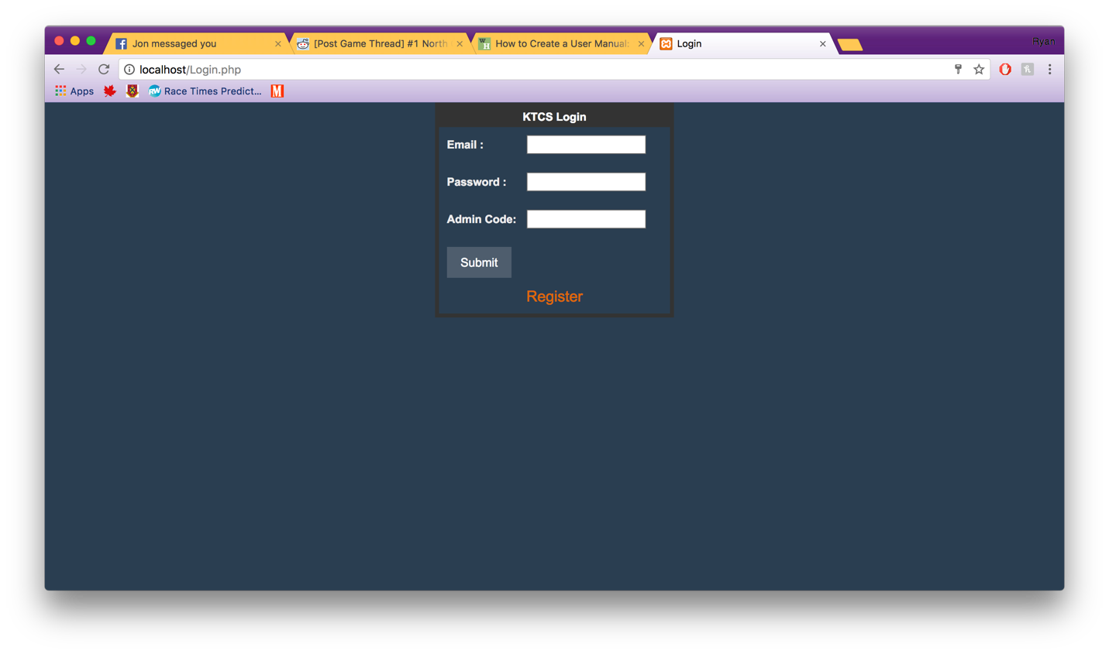
2. This will launch you to the Register page where you should fill out all of the fields then click Submit to complete.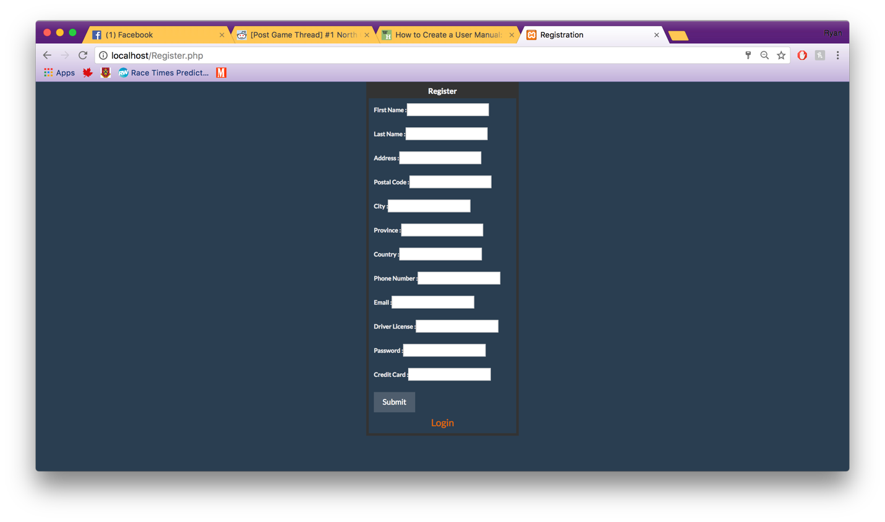
3. If all needed information is entered this will launch you back to the Login screen which you will be allowed to log in with your new account.

# Login

1. Enter login information as you entered it in the register page. Click submit to Login.



# Find all cars to rent on a day

1. On the homepage select the day you would like to see what cars are available and then in the Location ID dropdown select the “All…” option and click submit.

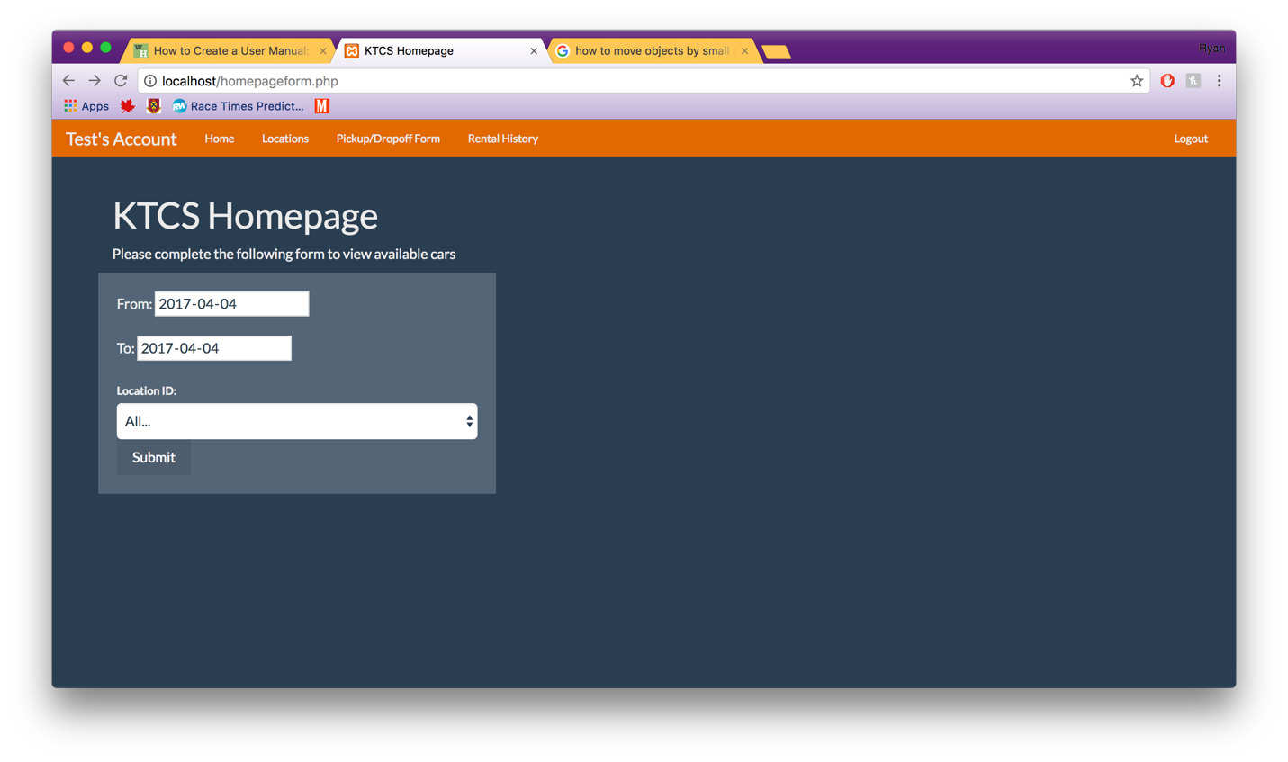

1. This will show you all the available cars for the date range you selected.

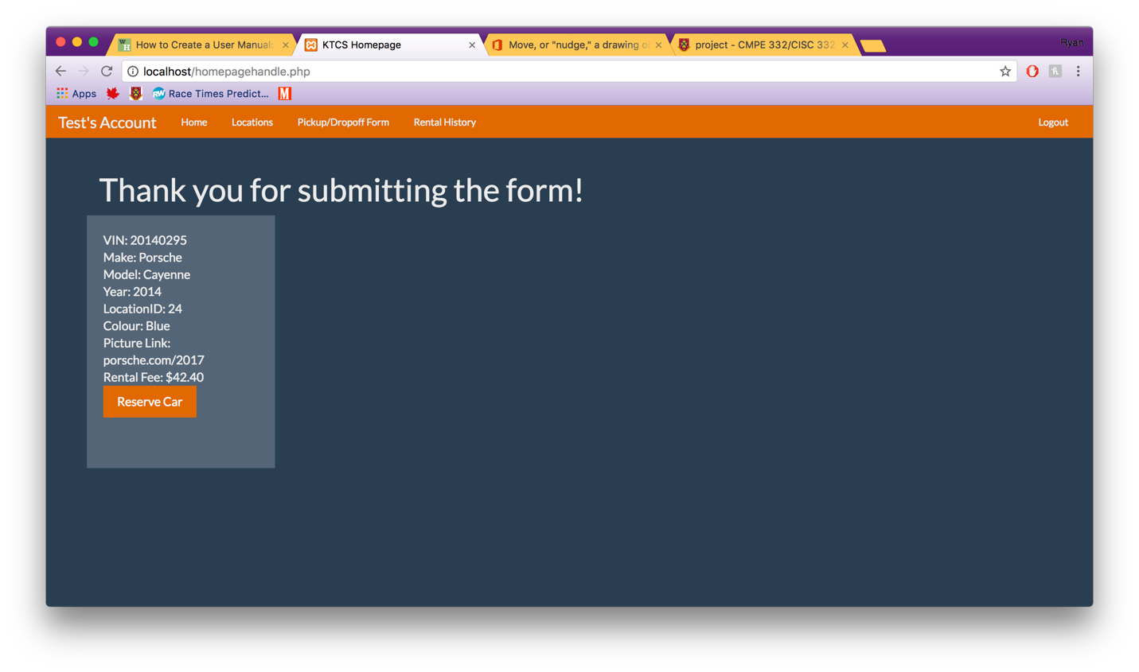

# Reserve a Car

1. On the homepage select the day you would like to see what cars are available and then in the Location ID dropdown select the location you would like to see



1. Once you have found a car you would like to reserve for the previous dates you selected click the Reserve button



1. Once submitted it will give you an access code which you will need to get into the car so save it.

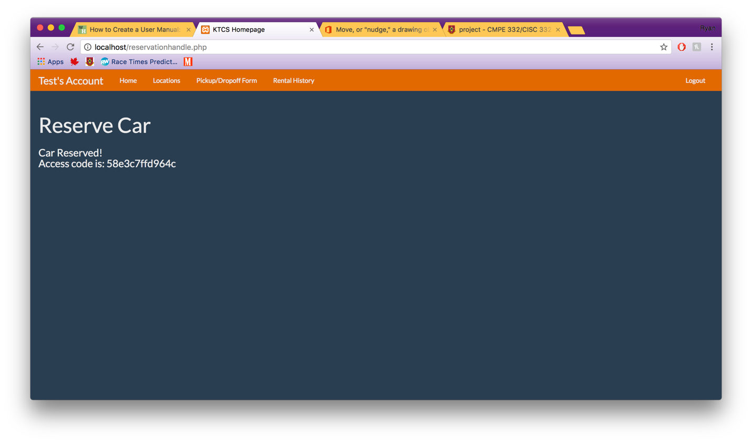

# Find all Locations

1. Click the Locations tab at the top of any page.



# Pick up a Car

1. Click on the Pickup/Dropoff tab at the top it will bring you to the following page. Where you fill out the odometer reading and car status and click submit. Then you are set to drive

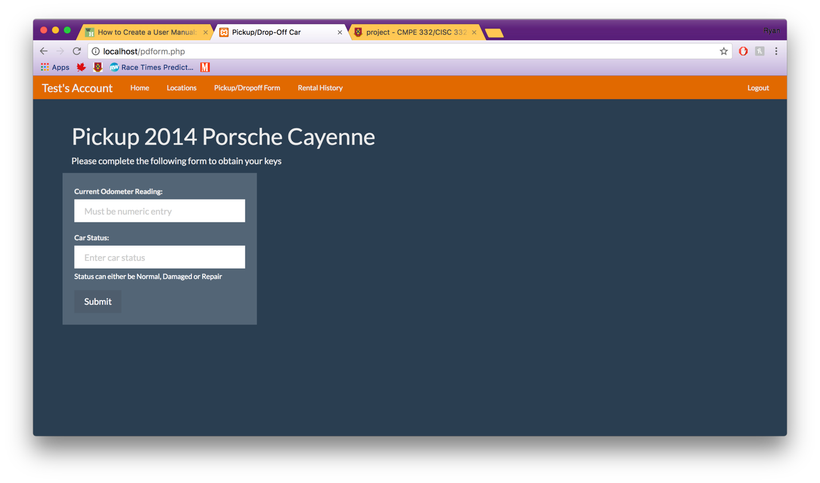

# Drop off Car and Provide Feedback

1. Once you have completed the pickup form you can reload the pickup/dropoff form tab which will then load the dropoff form, like the one below. Then complete the form and click submit to complete the dropoff. You can provide feedback on this screen as well.

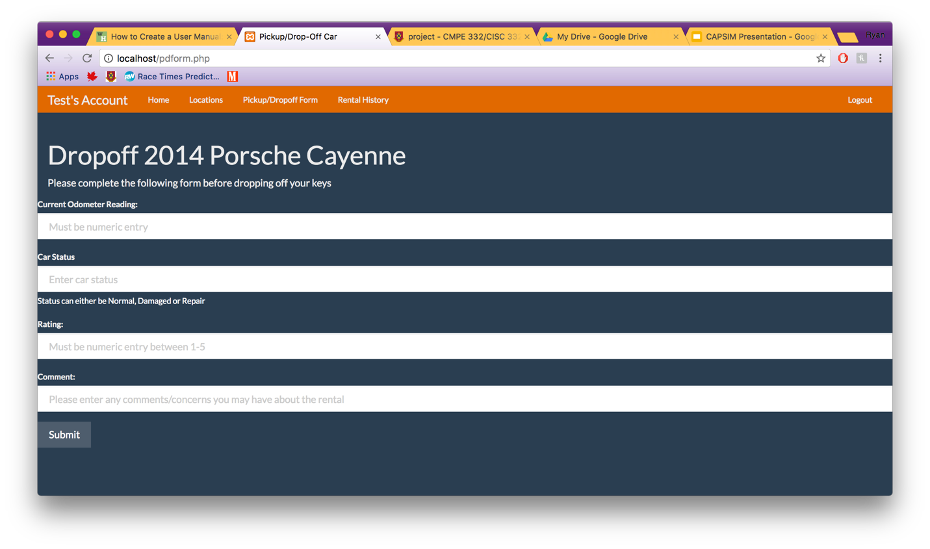

# Rental History

1. Click the Rental History tab and a history of your rentals will appear like the diagram below.

